Class Diagram RAS

Class Diagram Design

Sequence diagrams

Add Medicine

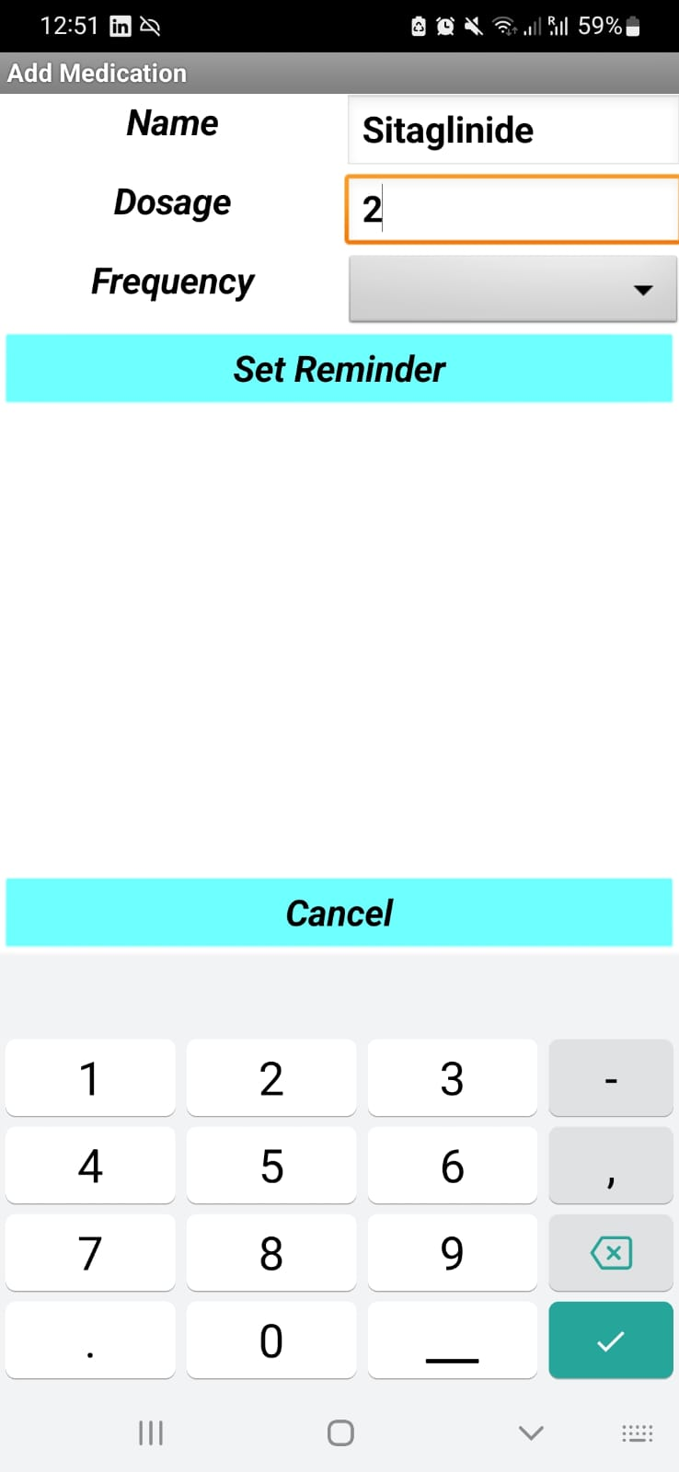

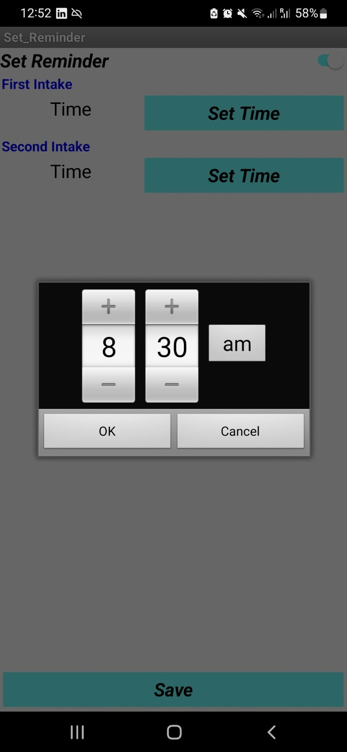

Show Medicine

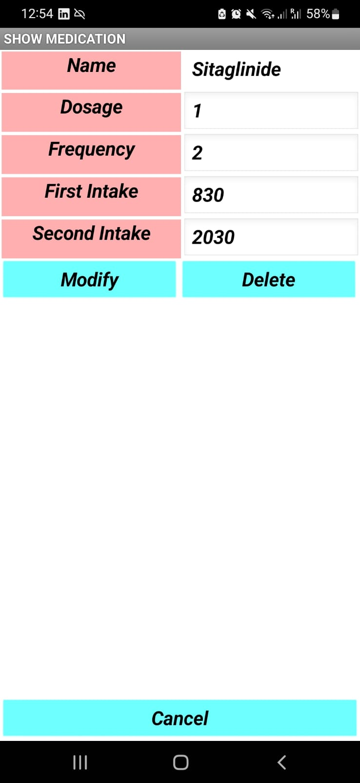Modify Medicine

Delete Medicine

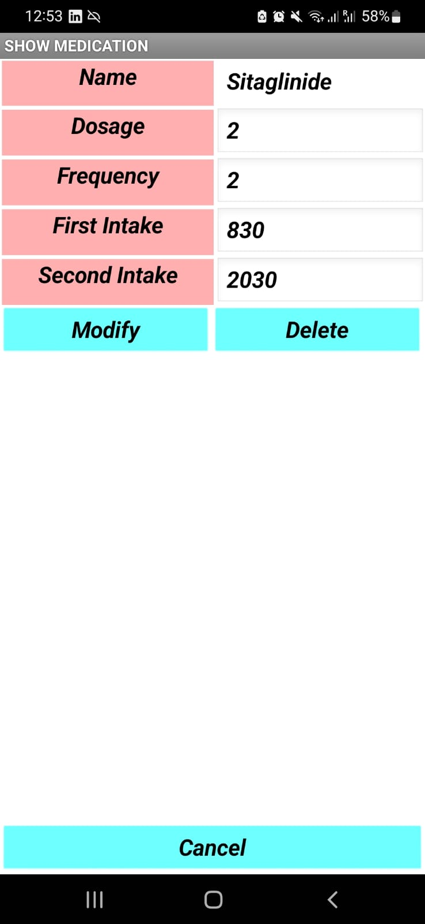

Turn On Reminder

Restock

State Diagram

